From Vibe Coding to Cyber Coding: Steering AI with Targets and Feedback to Recover Forrester's World2 Model
@Nick · University of New Mexico · Oct 3, 2026

Abstract
Vibe coding is programming by prompting an AI and accepting code that runs, often without reading it. A prompt like "write me a Doom-like game" gives the AI no target, so nobody can say whether the result is right. This paper proposes cyber coding (from the Greek kybernētēs, steersman), a general approach in which AI-assisted programming is steered by targets and feedback. The human sets a target the output must match, the AI produces the output, and the gap between the two drives the next correction. It is the balancing loop of system dynamics, applied to coding itself. Work proceeds in stages small enough for the human to read, so the human can steer, and every stage is kept once it passes its check. In the terms of distributed cognition, the kept stages are residua: learning artifacts a reader can return to and rebuild understanding from. Existing work is recovered first, with the original as the target. New goals then become new targets, each with its own check.
The method is demonstrated by recovering Jay W. Forrester's World2 model from World Dynamics (1971) in Python, then extending it. The book supplied every recovery target: the scanned DYNAMO listing, the glossary, and the figures and text of Chapter 4. Three versions were built in stages: a card-for-card isomorph, a version with readable names, and a modern version. All three agree to rounding error and reproduce all twelve Chapter 4 figures across four experiments. The checks also exposed three statements in Forrester's text that disagree with his own plots, and an independent implementation whose policy switch fires one step earlier than DYNAMO's definition gives. The modern version was then extended into an interactive web app (Plotly Dash) for changing the model's parameters, checked against the same runs. Code and data are openly available (DOI 10.5281/zenodo.23126731).

1. Introduction
The founding models of system dynamics live on paper. Jay W. Forrester published them as listings in DYNAMO, the simulation language of the 1960s and 1970s: the firm of Industrial Dynamics (1961), the city of Urban Dynamics (1969) and the world of World Dynamics (1971). The equations are still in the books. The means to run them, read them closely and change them are mostly gone, because almost no one can run DYNAMO today.
AI coding assistants can now translate a listing like these into a modern language in an afternoon. The popular way to use them is what Karpathy (2025) named vibe coding: describe what you want, accept the code the AI writes, and judge it by whether it runs. For a weekend project, that is often enough.
For recovering a classic model it falls short in two ways.
The first is correctness. Recovering a model means producing code that does what the original did. Vibe coding never states what the output must match, so it has no way to tell. A prompt like "write me a Doom-like game" gives the AI no target, and it fills the gap with its own average idea of Doom. A prompt to "convert this DYNAMO listing to Python" will produce code that runs and curves that look plausible. Whether they are Forrester's curves is a separate question, and plausible curves can be wrong in ways a glance misses. In the case reported here, an independent and carefully written Python version of the same model fires one policy switch a single 0.2-year step earlier than DYNAMO's definition gives, because of floating-point drift in its clock. Its results differ by up to 1.8%.
The second is learning. When an AI writes all the code at once, the human ends up with a program and without an understanding of it. For a model like World2, the understanding is the point. Forrester built system dynamics as a way of thinking about feedback, and his models are teaching objects as much as forecasts. Code the reader did not see take shape is code the reader cannot easily explain, extend or trust.
This paper proposes an alternative, cyber coding, named for the Greek kybernētēs, steersman, the word Wiener (1948) drew on to name cybernetics. In cyber coding, AI-assisted programming is steered by targets and feedback. The human names a target outside the AI that the output must match. The AI produces the output. A check measures the gap between output and target, and the gap drives the next correction. The work proceeds in stages small enough for the human to read, and each stage is kept once it passes its check.
Those kept stages matter beyond their role in steering. In the language of distributed cognition, they are residua of the work: artifacts left in the environment that a learner can return to, compare and rebuild understanding from. A program built by cyber coding leaves a trail of readable intermediate forms behind it, each checked, and each a step a learner can retrace.
The method is shown on a complete case, Forrester's World2 model (Forrester, 1971/1973). It was recovered from the DYNAMO listing in World Dynamics and translated to Python in three stages: a card-for-card isomorph, the same code with readable names, and a modern version. It was then extended into an interactive web app. Every stage had a target outside the AI, beginning with the book itself. All three versions reproduce the twelve figures of the book's Chapter 4 across its four experiments, and the app reproduces the same runs exactly. Along the way, the checks found three statements in Forrester's text that disagree with his own plotted output, and a policy switch in the independent version that fires one step earlier than DYNAMO's definition gives.
The paper makes four contributions. It defines cyber coding and grounds it in two older ideas: the balancing feedback loop of cybernetics and system dynamics, and Simon's (1962) argument that complex systems are built from stable intermediate forms. It documents a full worked case, with code, checks and data openly available. It shows that different kinds of checks catch different errors, so a cyber coder needs more than one. And it gives a distributed-cognition account of the collaboration in which the intermediate stages, usually treated as scaffolding to throw away, become the learner's main resource.
Section 2 defines cyber coding. Section 3 explains enough DYNAMO to follow the case. Sections 4 to 6 describe the recovery of World2, its validation and its findings. Section 7 extends the recovered model into an app. Section 8 analyzes the collaboration and its residua. Section 9 applies the method beyond World2, and Section 10 concludes. An appendix gives a one-page checklist.

2. Cyber coding
Cyber coding is AI-assisted programming steered by targets and feedback. This section gives its two roots and its basic loop, its four principles, how it extends existing work, and the second loop it closes.

2.1 Two roots
The first root is cybernetics. Wiener (1948) took the name from kybernētēs, the steersman, because the central mechanism of control is the one a helmsman uses: compare where the ship is heading with where it should be heading, and act on the difference. Engineers call this negative feedback. Forrester came to system dynamics from the same tradition. He began his career building servomechanisms at MIT, and he built system dynamics on the feedback concepts of control engineering (Forrester, 1961). Its models are made of feedback loops, and the goal-seeking kind, the balancing loop, works by acting on the gap between a goal and the current state.
Cyber coding turns that loop on the act of programming. The target is the goal. The AI's output is the current state. A check measures the gap between them, and the human's correction acts on it (Figure 1).
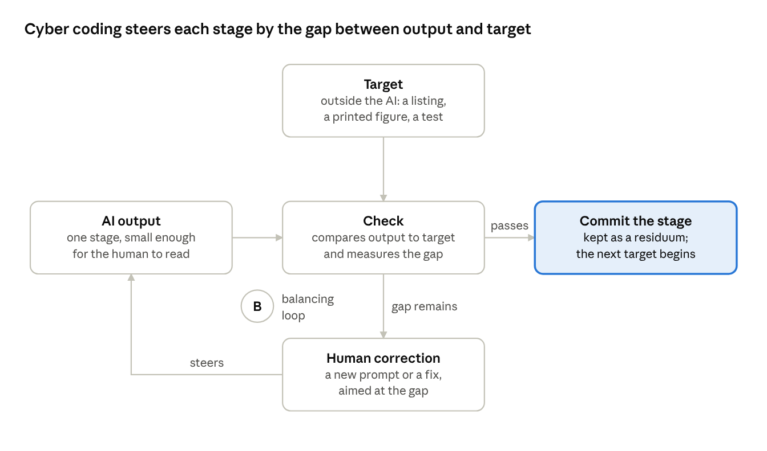
Figure 1. The cyber coding loop for one stage
The second root is Simon's (1962, 1996) parable of two watchmakers, Tempus and Hora. Both make watches of a thousand parts, and both are often interrupted by customers' calls. Tempus builds each watch in one piece, so a watch he sets down falls apart and he must start again. Hora builds stable subassemblies of about ten parts, then assembles those into larger ones, so an interruption costs him at most the few parts in hand. Simon computes that if an interruption comes on average once in a hundred parts, Tempus takes about four thousand times as long as Hora to finish a watch. Complex systems, he concludes, are built from stable intermediate forms.
Vibe coding is Tempus. A prompt for a whole program asks for the watch in one piece. When the result fails, nothing marks which part failed, so the coder either starts over or searches the whole program. In AI-assisted coding the interruptions are many: an error in the AI's output, a misunderstanding in the prompt, a session that runs out of context, a human who steps away. Cyber coding is Hora. Each stage is a subassembly, and a failure costs only the work since the last stable stage.
One difference matters. Hora's subassemblies are parts of a whole: ten parts make a module and ten modules a larger module. The stages in this paper's case are mostly successive whole versions, each changing one thing. The property that carries over is the one Simon's arithmetic depends on: an error or interruption costs only the work done since the last stable form.

2.2 Four principles
An external target. Each stage has a target that exists outside the AI and that the output must match: an original listing, a printed figure, a sentence in the source text, a test someone else wrote, a recorded run of the original program. A target the AI writes for itself, such as its own tests or its own summary of the goal, does not close the loop, because the same misunderstanding can sit in both the target and the output.
A check against it. Each target comes with a check that measures the gap: a bit-for-bit comparison, an overlay of output on a printed figure, a list of numbers from the text, a screenshot of a page. Checks differ in what they can see. In the case below, the numeric checks on the interactive app passed on the first try, while looking at the page in a browser found ten problems of layout and appearance that no number could reveal.
Stages small enough to read. In the loop, the human is the comparator for anything a check cannot measure, and a human can compare only what they can read. A stage that changes one thing can be read against the stage before it. A thousand lines generated at once cannot, and the human's part in the loop shrinks to accepting it.
Every passing stage kept. A stage that passes its check is committed to version control before the next stage begins, and it stays in the repository. Only then is it a stable subassembly in Simon's sense: a later stage can fail, or be undone, without losing it. Kept stages also have a second life. In the terms of distributed cognition, they are residua (Hutchins, 1995): traces of the work that remain in the environment after it is done, which a learner can return to and use to rebuild understanding. Section 8 develops this point.

2.3 Recover, then extend
Cyber coding works best when it begins from something that already exists. The original program, listing or system is the first target, and recovering it faithfully gives a foundation whose correctness is known. New goals then become new targets, each with its own check. In the case below, the new goal was an interactive app, and its check was that the app, set to the book's experiments, reproduce the validated runs exactly. When a new goal requires changing the recovered foundation itself, the change reopens a stable subassembly, and the foundation's full set of checks is run again before anything is built on it.

2.4 Two loops
Staging closes a second loop. The first loop moves the code toward its target. The second moves the human's understanding toward the code: at each stage the human reads what changed, compares it with what they expected, and corrects their picture of the program. In vibe coding the second loop is open. The human never compares an expectation with the code, so their understanding does not move. In cyber coding, stages small enough to read keep both loops closed, and the kept stages let a later learner run the second loop again, from the beginning.

3. DYNAMO for modern readers
World2 is written in DYNAMO, the simulation language Forrester's group at MIT used for system dynamics from about 1960 into the 1980s. A reader who knows a modern language can follow a DYNAMO listing once six conventions are clear. Each one is also a trap for a translation that reads the listing too literally.
Cards. A listing is a deck of punched cards, one statement per card. Each card carries an equation number and a type letter: L for a level (a stock), R for a rate (a flow), A for an auxiliary, C for a constant, N for an initial value, T for a table, and S for a supplementary variable, computed only for output. An X card continues the card above it. The first cards of World2 read:
1 L P.K=P.J+(DT)(BR.JK-DR.JK)
1.1 N P=PI
1.2 C PI=1.65E9
2 R BR.KL=(P.K)(CLIP(BRN,BRN1,SWT1,TIME.K))(BRFM.K)(BRMM.K)(BRCM.K)(BR
X PM.K)
Population P is a level. It starts at 1.65 billion, and it changes by the birth rate BR minus the death rate DR.
Time suffixes. Every variable carries a suffix that says when it is computed. K is the present moment, J is one time step earlier and L one step later. A level at K is computed from its value at J and the rates over the interval JK just ended. Auxiliaries are computed at K, and rates are computed at K for the interval KL ahead. Each step therefore runs in a fixed order: levels, then auxiliaries, then rates. The time step DT is 0.2 years and the run goes from 1900 to 2100. This is Euler integration, written out by hand on every level card.
Sorting. DYNAMO did not execute a listing from top to bottom. Its compiler sorted the auxiliary equations so that each is computed after everything it uses. In World2, equation 3 uses the material standard of living MSL, which equation 4 defines:
3 A BRMM.K=TABHL(BRMMT,MSL.K,0,5,1)
4 A MSL.K=ECIR.K/(ECIRN)
Python runs top to bottom, so a faithful translation must do the compiler's sorting itself. A translation that copies the listing in its printed order fails on the first step, because MSL does not exist yet. Give MSL a starting value to get past that error, and the translation runs, but it quietly computes BRMM from the MSL of the step before, at every step.
Tables. Many relationships in World2 are tables rather than formulas. TABHL(BRMMT,MSL.K,0,5,1) reads the table BRMMT at the value of MSL, with x running from 0 to 5 in steps of 1, and interpolates linearly between entries. Beyond either end it holds the end value. TABLE works the same way for inputs that are expected to stay in range, and flags any that leave it. No input leaves its range in any of the book's runs.
Switches. CLIP(A,B,X,Y) returns A while X is at least Y, and B otherwise. World2 uses it as a policy switch. In CLIP(BRN,BRN1,SWT1,TIME.K), BRN is the normal birth rate up to and including the switch year SWT1 (1970), and BRN1 is the rate after it. In the standard run each pair of values is equal, so the seven switches change nothing. Forrester's experiments change the second value of a pair. The moment of switching depends on an exact comparison with TIME, and TIME is built by adding 0.2 over and over. In binary floating point 0.2 has no exact representation, so the sum drifts away from round numbers, and the computer's "1970" can land a hair before or after 1970. A translation has to keep TIME on the grid, or a switch fires a step early or late. Section 6 shows what that costs.
Output. PLOT cards name the variables to print and the scale of each:
PLOT P=P(0,8E9)/POLR=2(0,40)/CI=C(0,20E9)/QL=Q(0,2)/NR=N(0,1000E9)
Population is plotted with the letter P on a scale of 0 to 8 billion, the pollution ratio with the digit 2 on a scale of 0 to 40, and so on. Every variable on a plot shares one frame, each on its own scale. The book's figures are these printer plots: rows of characters, one row every four years (PLTPER = 4), with smooth curves drawn through them by hand for publication. Section 4.2 treats the printed characters as the data and the hand-drawn curves as decoration.
Table 1 shows how the first Python version keeps this notation visible.
DYNAMO | Meaning | Version 1
P.K | population at the present step | P_K
P.J | population one step earlier | P_J
BR.JK | birth rate over the step just ended | BR_JK
BR.KL | birth rate over the step ahead | BR_KL
CLIP, TABHL, TABLE | switch and table lookups | functions with the same names and arguments
DT, LENGTH | time step and end of the run | DT, LENGTH
Table 1. DYNAMO notation and its form in version 1.
With that notation, card 1 becomes one line of Python, with the card kept above it as a comment:
# 1 L P.K=P.J+(DT)(BR.JK-DR.JK)
P_K = P_J + DT * (BR_JK - DR_JK)
Read this way, World2 is a set of coupled difference equations solved by Euler's method with a step of 0.2 years. DYNAMO adds two things to that: notation that makes the timing of every value explicit, and a compiler that hides the order of computation. A translation should keep the first and undo the second.

4. Recovering World2 step by step
The recovery ran in five stages. Each had its own target, taken from the book, and its own check, and each was kept in the repository once it passed (Table 2).
Stage | Target | Check | Result
Transcription | Scans of the listing (Appendix B) and the glossary (Appendix C) | Line-by-line rereading; every name in both; the equations printed again in the chapters | 127 lines and 111 terms; two scan flaws resolved
Version 1, isomorph | The DYNAMO cards | Overlays on all twelve figures of Chapter 4 | The curves land on the printed points
Version 2, readable names | The glossary | Bit-for-bit comparison with version 1 | Identical in all four experiments
Version 3, modern | Version 1's runs | Largest relative difference from version 1 | At most 5.1 parts in 10^15
Diagram | The equations, with the book's Figure 2-1 as a starting point | A script compares parsed links with a sign list | 66 nodes, 79 signed links and 7 flows
Table 2. The stages of the recovery, each with its target and check.

4.1 Transcription
The listing and the glossary were transcribed from scans of the second edition, then each column was reread from zoomed crops. Two places in the scan were ambiguous. The AI flagged one, I questioned the AI's reading of the other, and both were settled against a second printing of the same equations in the book's chapters. Card 22.1 reads CIAFN= 3 with its decimal point lost; the value is .3. The closing parenthesis of equation 9 is smudged. As a structural check, every name in the listing has a glossary entry, and every glossary entry is used in the listing, apart from DT and LENGTH, which are DYNAMO's own run settings.
The pitfall here is a scan error that still parses. CIAFN=3 is a valid number, and a model built with it would run. Only a second source could show it was wrong.

4.2 Version 1: the isomorph
Version 1 translates the listing card for card. Every card appears as a comment with its Python translation directly below it. Names keep their time suffixes (Table 1), and CLIP, TABLE and TABHL keep their names and argument order, so the file reads side by side with the book. Inside the time loop the auxiliaries appear in the order DYNAMO's compiler would have sorted them, each tagged with its equation number, and TIME is rounded at each step to keep the switches on the grid. I chose this starting point deliberately: a close isomorph first, so that every later version could be checked against a translation whose relation to the book is plain.
The target for this stage was the book's own output. Chapter 4 prints twelve figures from Forrester's runs: the standard run and three experiments in which he changed policies in 1970. Each figure was scanned and straightened, its dotted gridlines were located automatically, and version 1's run of the same experiment was drawn on top, each variable mapped onto the figure's own printed scale. Figures 2 to 5 show all twelve.¹
The black characters on each page are the points Forrester's DYNAMO run printed, one row every four years. The black ink curves were drawn through them by hand for publication, so where the ink and the characters disagree, the characters are the data. Two places show this clearly: near the capital-investment peak in the book's Figure 4-5, and at the death-rate spike in its Figure 4-8, which falls between two plotted rows and so could not be drawn at its true height.
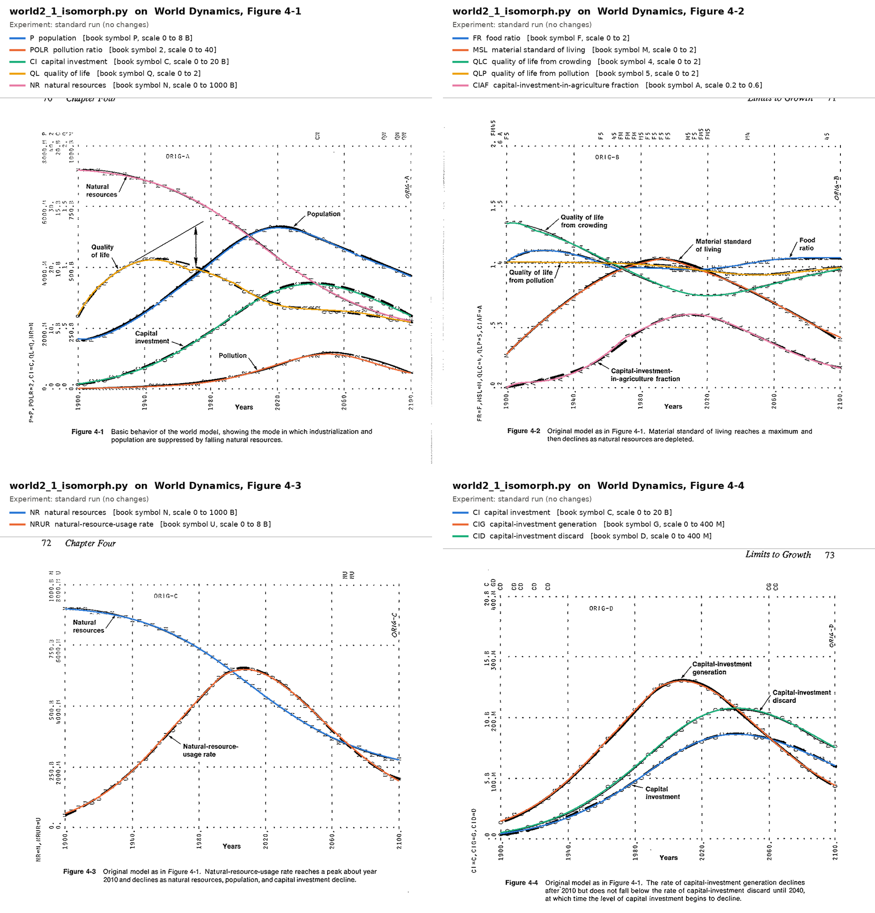
Figure 2. The standard run. Version 1's curves (in color) on the book's Figures 4-1 to 4-4. Each header lists the variables, the book's plotting symbol for each and its scale.
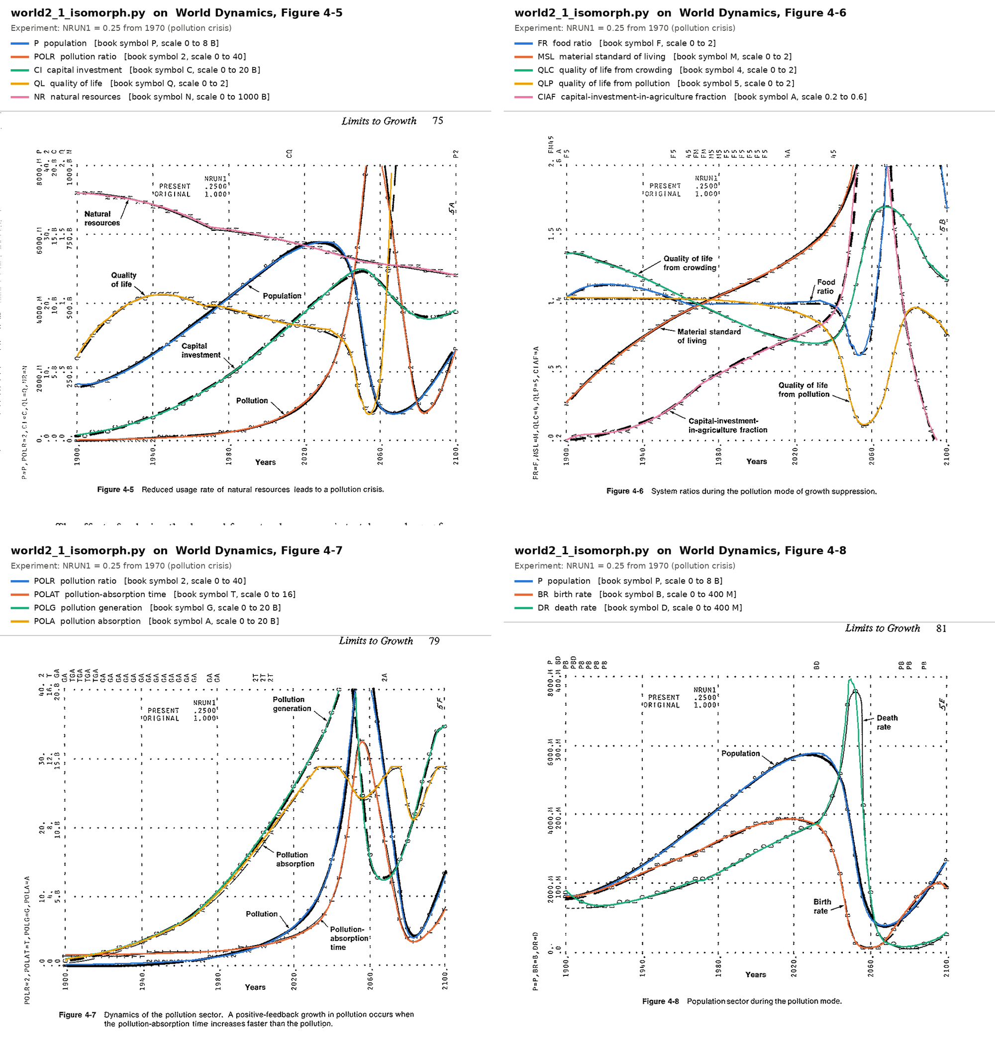
Figure 3. The pollution crisis: natural-resource usage cut to 25% of normal in 1970, on the book's Figures 4-5 to 4-8.
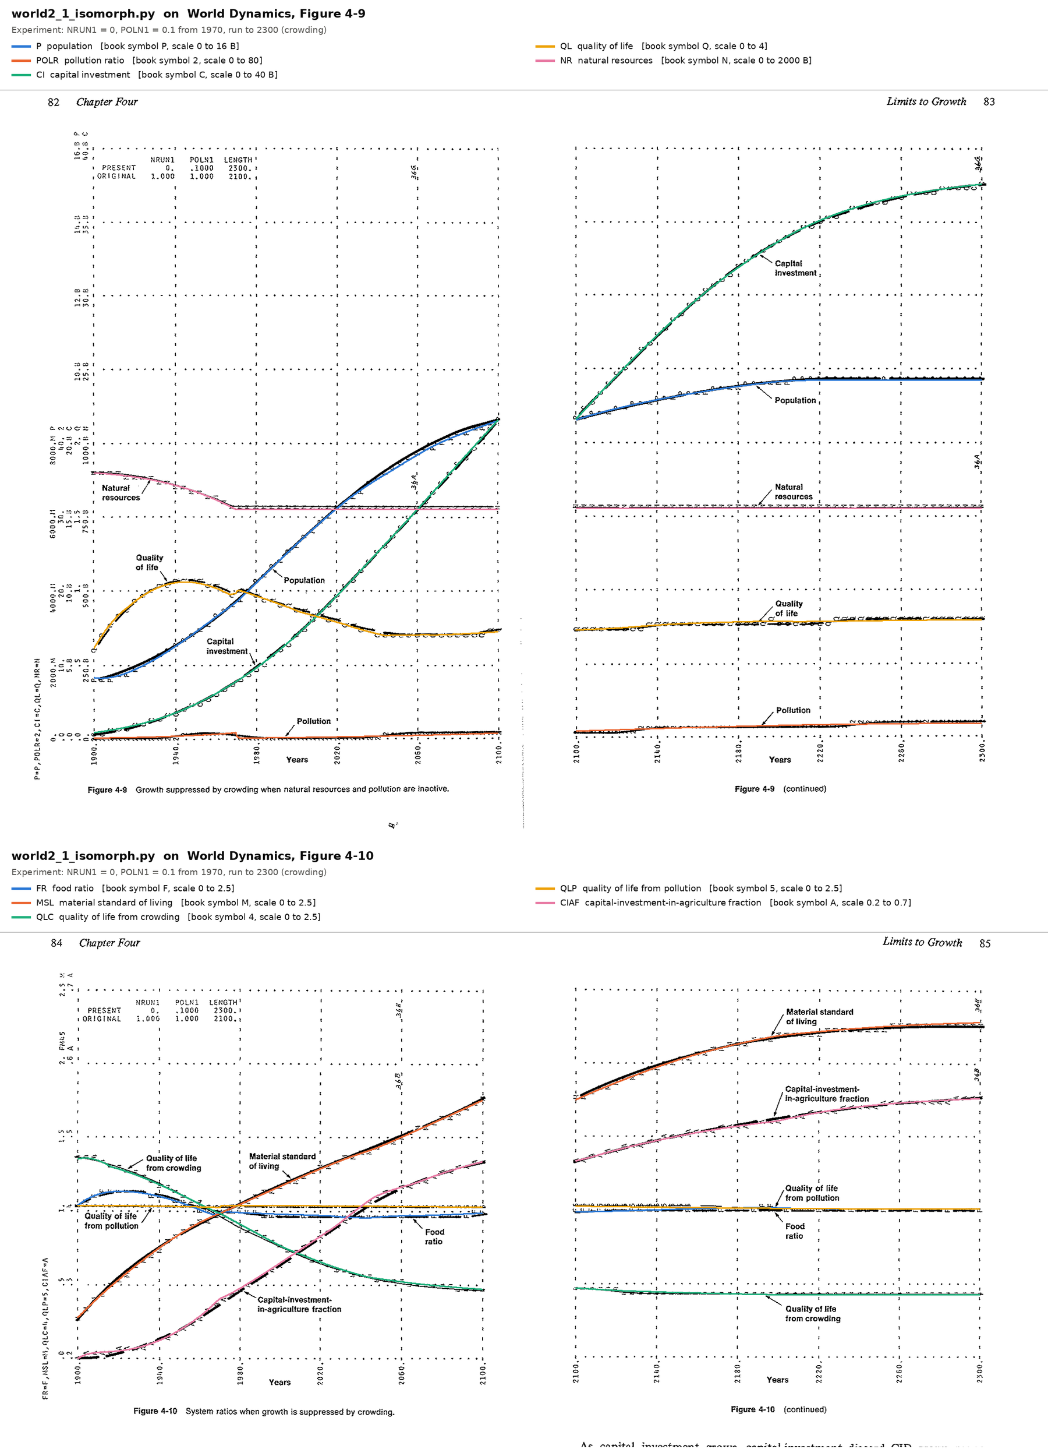
Figure 4. Crowding: natural-resource usage cut to zero and pollution to 10% of normal in 1970, run to 2300, on the book's Figures 4-9 and 4-10, each printed across two pages.
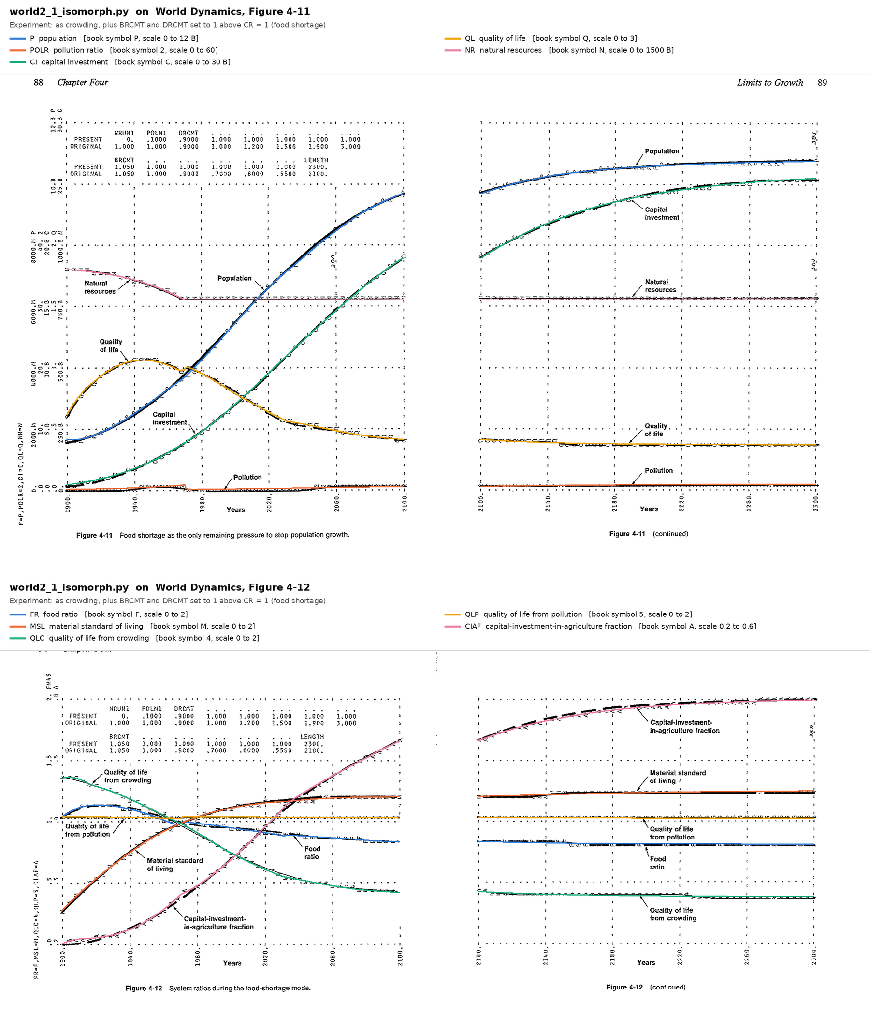
Figure 5. Food shortage: the crowding changes, plus crowding's effect on births and deaths removed above a crowding ratio of 1, on the book's Figures 4-11 and 4-12.
In every figure, in all four experiments and out to the year 2300, the colored curves pass through the printed characters. Section 5 adds numerical checks against statements in the book's text.
The pitfalls at this stage were the ones Section 3 describes: the compiler's sorting, the switch timing, and the J and K bookkeeping. The rates used to update a level must be the ones computed in the previous step, before they are overwritten.

4.3 Version 2: readable names
Version 2 keeps every line of version 1 in the same order and replaces each abbreviation with the book's own definition from the glossary. P becomes population, MSL becomes material_standard_of_living, and the J and JK values take a _prev suffix, so card 1 reads population = population_prev + dt * (birth_rate_prev - death_rate_prev). The DYNAMO cards stay as comments, so the file also works as a lookup between the two sets of names.
The check was bit-for-bit equality with version 1 in all four experiments. Renaming changes no arithmetic, so any difference at all would mean a mistake. Demanding identity rather than closeness also catches a quieter error: a "tidying" that reorders a product or regroups a sum changes the last digit of a floating-point result. The same twelve overlays were made for version 2, and they are pixel-for-pixel identical to version 1's apart from the header naming the script.

4.4 Version 3: modern Python
Version 3 rewrites the program as it would be written today, under one constraint I set: no class hierarchy, and the single time loop stays visible from top to bottom. The model becomes a function, simulate(policy, tables). The seven policy switches sit in one dictionary and the 22 tables in another, the tables are read with numpy, and each level is updated in place at the end of the step. The J and K bookkeeping disappears, because every rate is computed from the old levels before any level changes.
The target for this stage was version 1's runs, now trusted. numpy's interpolation can differ from version 1's arithmetic in the last digit, so the check asked for agreement to within rounding rather than identity. Over every recorded variable at every step, the largest relative difference from version 1 is at most 5.1 parts in 10^15 in any of the four experiments (Section 5). The overlays for version 3 are again pixel-identical to version 1's. The pitfall at this stage is updating a level before every rate has been computed from the old levels.

4.5 The diagram
My starting materials included the book's causal diagram, its Figure 2-1. The project's diagram was generated from the equations instead. Every variable on the right side of an equation gets an arrow into the variable on the left, and each arrow's sign comes from the algebra (a numerator gives +, a denominator gives −) or from the slope of its table. Every table in World2 only rises or only falls, so each link has a single sign everywhere. A script rebuilds the diagram, in Mermaid, from the listing, and stops if the links it parses disagree with its list of signs. A diagram generated from the equations can be checked against them, link by link.

5. Validation
Four kinds of check were run against four different targets, and each could see errors the others could not (Table 6, at the end of this section). All of them can be repeated from the repository; only the overlays need a copy of the book.

5.1 The four experiments
Chapter 4 of World Dynamics runs the model four ways. The changes are the ones printed in each figure's margin (Table 3). The policy changes take effect after 1970. The food-shortage run also changes two tables, which apply from the start but have no effect until the crowding ratio passes 1, in 1967.6.
Experiment | Book figures | Changes from the standard run
Standard run | 4-1 to 4-4 | none
Pollution crisis | 4-5 to 4-8 | natural-resource usage NRUN1 = 0.25 (was 1)
Crowding | 4-9, 4-10 | NRUN1 = 0; pollution POLN1 = 0.1 (was 1); run to 2300 (was 2100)
Food shortage | 4-11, 4-12 | the crowding changes, plus the crowding tables BRCMT and DRCMT set to 1 above a crowding ratio of 1
Table 3. The book's four experiments.
Versions 1 and 2 ran each experiment the way a DYNAMO user would have: by editing the changed cards in a copy of the program and running it again. Version 3 ran them through the arguments of simulate().

5.2 Agreement between the versions
Table 4 gives the largest relative difference from version 1, over every recorded variable at every time step.
Experiment | Time steps | Version 2 | Version 3
Standard run | 1,001 | bit-identical | 1.3 parts in 10^15
Pollution crisis | 1,001 | bit-identical | 5.1 parts in 10^15
Crowding | 2,001 | bit-identical | 1.4 parts in 10^15
Food shortage | 2,001 | bit-identical | 0.54 parts in 10^15
Table 4. Agreement with version 1.
No table input left its range in any experiment, which is the condition DYNAMO's TABLE function would have flagged.

5.3 Overlays on the book's figures
Figures 2 to 5 in Section 4 are the overlay check. Each scanned page was straightened (by up to 2.2 degrees on these scans), its dotted gridlines were found automatically, and every value was mapped onto the figure's own printed scale. The two-page figures were aligned page by page. This check sees the shape and timing of every curve at the resolution of the printer plots, one row every four years, across all twelve figures. It cannot see a difference smaller than a character's width on the page.

5.4 Statements in the book's text
Forrester describes his runs in the text of Chapter 4, often with numbers. Twenty-one of those statements were checked against version 1 (Table 5).
Book says (page) | Version 1
Standard run
Population peaks in 2020 (69) | 2020.4, at 5.30 billion
Natural-resource usage peaks about 2010 (Fig. 4-3) | 2008.8
Capital-investment generation declines after 2010 (Fig. 4-4) | peaks in 2008.8
It stays above discard until 2040, when capital investment begins to decline (Fig. 4-4) | crosses in 2040.8; capital investment peaks in 2040.8
The agricultural capital fraction rises from 0.2 to 0.32 over the first hundred years (72) | peaks at 0.321 (2011)
Material standard of living peaks at about 2000 (72) | 1993.6
Pollution peaks in 2060 at some 6 times its 1970 level (70) | 2050.6, at 7.1 times
Quality of life peaks around 1960 (70) | 1945.2
Pollution crisis
Pollution rises to more than 40 times its 1970 level (75) | 54 times
Population falls in 20 years to one-sixth of its peak (75) | one-sixth of peak in 2060.6: 29.4 years after the peak, 17.4 after it falls below 90% of the peak
Quality of life dips suddenly and deeply, then rises fast after 2060 (76) | falls to 0.19 in 2054, rises to 5.3 by 2070
Crowding
Population rises to about 9.7 billion (81) | 9.69 billion
A crowding ratio of 2.65 (81) | peaks at 2.71
Population is essentially stable by 2200 (81) | 9.65 billion in 2200, 9.69 billion in 2300
Capital investment rises to 38 billion units (84) | 37.5 billion
A capital-investment ratio of 3.9 (84) | 3.88
Material standard of living rises to 2.3 times its 1970 value (84) | 2.32 times
The agricultural capital fraction rises from 0.28 in 1970 to 0.55 in 2300 (84) | 0.280 and 0.552
Quality of life drops to about 0.8 of its 1970 value (86) | 0.81
Food shortage
Population rises to 10.8 billion (88) | 10.75 billion
The food ratio declines to 0.77 (90) | 0.81
Table 5. Twenty-one statements in Chapter 4, checked against version 1.
Most statements agree with version 1 to the precision the text implies; Forrester often writes "about" or "some", and rounds. In three cases the text is contradicted by the book's own plots, and Section 6.1 shows that the plots side with version 1. The remaining gaps, such as a crowding ratio of 2.65 against 2.71, concern quantities the figures do not plot, and are small.

5.5 An independent implementation
pyworld2, version 1.1 (Vanwynsberghe, n.d.), is a separate Python implementation of World2 with a different program structure. Over all 1,001 steps of the standard run, its largest relative difference from version 1 is about 2 parts in 10^15 for every level and the main auxiliaries. In the pollution-crisis experiment the two differ by up to 1.8%. Section 6 traces the cause.

5.6 What each check can see
Check | Target | Catches | Misses
Overlays | The book's printed output | Wrong structure, wrong tables, wrong timing at the scale of years | Anything smaller than a character on the page
Statements in the text | Forrester's description of his runs | Wrong peaks, levels and ratios | Whatever the text does not mention; errors in the text itself
Agreement between versions | The previous, trusted version | Any translation error, down to the last digit | An error shared by every version
An independent implementation | Someone else's reading of the same listing | Differences in how the listing was interpreted | An interpretation both share
Table 6. Four checks and what each can and cannot see.
No single row of Table 6 would have been enough. The overlays could not see a 0.2-year shift in a switch; the cross-version check could not see an error in version 1 itself; and only the comparison with an independent implementation exposed a question about how a switch should fire.

6. Findings
The checks turned up a disagreement inside the book, a timing difference in an independent implementation, and a set of pitfalls any direct port of a DYNAMO model is likely to meet.

6.1 The book's text and its plots disagree in three places
Three statements in Chapter 4 disagree with the figures printed beside them:
- Pollution in the standard run peaks "in the year 2060 at some 6 times the level in 1970" (p. 70). The pollution curve in the book's Figure 4-1 peaks near 2050. Version 1 peaks in 2050.6, at 7.1 times the 1970 level.
- Quality of life "peaks around the year 1960" (p. 70). The book's Figure 4-1 shows the peak in the 1940s. Version 1 peaks in 1945.2.
- In the food-shortage run, the food ratio "declines to 0.77" (p. 90). In the book's Figure 4-12 the printed F characters level off near 0.81 on both pages. Version 1 levels off at 0.81.
In each case version 1 agrees with the plotted data, so the text's numbers are best read as approximate. The lesson for cyber coding is that a source can disagree with itself, so its targets need an order of authority. Here the printed output of Forrester's own program outranks his prose about it, because it is closer to the computation. That order is best decided before the checks begin; decided after a mismatch appears, it invites choosing whichever target agrees.

6.2 A one-step timing difference in an independent implementation
In the pollution-crisis experiment, pyworld2 differs from version 1 by up to 1.8%. The cause is how it builds its clock. It makes its time axis with numpy.arange, which takes its spacing from the first two values, 1900 and 1900.2. The number 1900.2 cannot be stored exactly in binary, so the spacing comes out as 0.20000000000004547, and after 350 steps the step meant to be 1970 is 1970.000000000016. At that step the switch's test, whether TIME is still at or before 1970, fails, and the new policy starts one step, 0.2 years, earlier than DYNAMO's definition gives with exact arithmetic.
As a diagnostic only, moving version 1's switch one step earlier makes the two programs agree to 1.3 parts in 10^15. The project's versions keep DYNAMO's definition of CLIP: the old value up to and including the switch year. A 0.2-year shift is far too small to see in the book's figures, so the book cannot settle which way Forrester's own run fired; the repository lists this as a known limitation. If DYNAMO advanced TIME by adding DT at each step, as its notation suggests, Forrester's own run may not have fired exactly on the grid either. pyworld2 is careful work, and the lesson concerns the size of the effect: a difference of one step, invisible in every figure, moves the results by up to 1.8%.

6.3 Pitfalls of a direct port
Table 7 collects the pitfalls a direct port is likely to meet, with the check that catches each.
Pitfall | What goes wrong | Caught by
Running the listing in its printed order | An auxiliary uses a value from the previous step | A check that every auxiliary is computed after everything it uses
Building TIME by repeated addition, or with numpy.arange | A switch fires a step early or late | An independent implementation; the exact step of each switch
Updating a level before every rate is computed | Rates mix old and new levels | Agreement with the previous version
A scan error that still parses | A wrong constant and a plausible run | A second printing of the same equation
Reading the hand-drawn curves as the data | False mismatches near peaks and spikes | Comparing against the printed characters
Taking the text's numbers as exact | False mismatches | Ranking the plotted output above the prose
Table 7. Pitfalls of porting a DYNAMO model, and the checks that catch them.

7. Extending World2: an interactive app
With the recovery done, I set a new goal: an app in which a reader can run the book's experiments and try policies of their own (Figure 6). It was built with Dash, a Python library for web apps, on top of version 3, in three stages, the third in two parts.
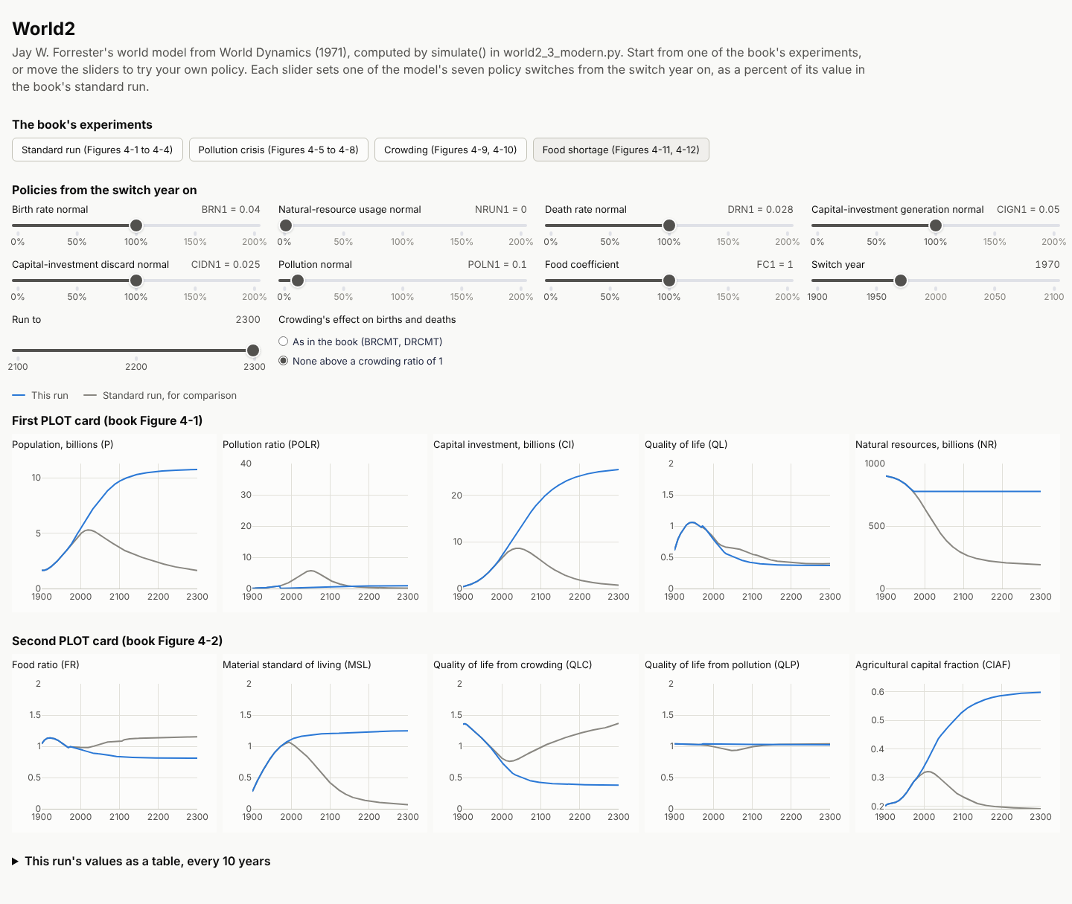
Figure 6. The app after its "Food shortage" button is pressed. Each chart shows the run in blue over the standard run in gray, on the scale the book uses for that variable.

7.1 A new target with an inherited check
The new goal came with a check the recovery had already paid for: set to the book's values, the app must reproduce the four validated runs exactly. One design rule made that check meaningful. The app holds no model of its own. It imports simulate() from version 3 and only draws what it returns, so there is still one copy of the model, and everything known about version 3 carries over to the app.

7.2 Three stages
Each stage added one capability and was checked before the next began (Table 8). Every stage but the first was also committed before the next began; Section 8.4 tells how that gap was found.
Stage | What it added | New idea in Dash | Numeric check | What looking at the page found
1 | The standard run, drawn as the listing's two PLOT cards | A page layout | Every curve is simulate()'s output, within 1.0 part in 10^15 of version 1 | Chart titles collided on a 1,024-pixel screen; a title was cut off; a developer toolbar covered the page; hovering drew two lines
2 | Sliders for the seven policy switches, the switch year and the end year | A callback: controls in, charts out | The book's settings give the pollution-crisis and crowding runs bit for bit | Labels repeated themselves; a purple accent competed with the data; sliders fell out of line; a focused slider covered its label
3a | simulate() takes the tables as an argument | none (a change to the model) | Old and new version 3 bit-identical in all four experiments; every earlier check rerun | nothing to look at
3b | Buttons for the four experiments, the standard run in gray, a control for the crowding tables | A second callback, chained to the first | All four experiments bit for bit, with the controls holding the book's values exactly | A style meant for slider labels split the crowding control's options; year labels crowded in 400-year runs
Table 8. The app's stages.

7.3 Two kinds of target
The numeric check passed at every stage on its first run. Looking at the page found ten problems, none of which any number could reveal. An app has a second target besides its numbers: it must be readable, at any screen width. The AI made that check itself, by loading the page in a headless browser, moving sliders and pressing buttons, and reading screenshots at three widths. A cyber coder extending a recovered model into an interface needs both kinds of target, and both kinds of check.

7.4 Floating point, again
The sliders set each policy as a percent of its standard value. Written as before * percent / 100, a slider at 100% turns the death rate normal of 0.028 into 0.028000000000000004, and the standard run is no longer bit for bit the standard run. Written as before * (percent / 100), 100% is exact, and 25% and 10% give the book's 0.25 and 0.1 exactly. The problem was caught while the sliders were being designed, because the stage's check demanded identity. It belongs to the same family as the slip in Section 6.2: a difference in the last digit that changes what a run means.

7.5 Reopening a stable subassembly
The food-shortage experiment changes two of the model's tables, which no policy switch can express, and simulate() accepted only a policy. Supporting it meant changing version 3 itself, the first change to the recovered model since it was validated. The change was made as its own stage (3a), separate from the interface work. The 22 table constants became one dictionary passed to simulate(), parallel to the policy, and the old way of running the experiment, overwriting the module's constants, was retired, since a web server answering several requests at once cannot safely share them. Every earlier check was then run again. Version 3's output was bit-identical to before in all four experiments, its own plot was pixel-identical, and the checks of Section 5 gave the same results. Only then was the app built on it.
One gap in the process surfaced during these stages: stage 2 overwrote stage 1 before stage 1 had been committed. Neither the numeric nor the visual check could see it. Section 8 takes it up.

8. Residua: the stages as learning artifacts
The stages of a cyber-coded program are kept for steering. In this project they also became the main resource for learning the program, for the person who built it and for anyone who comes after.

8.1 What the work leaves behind
Distributed cognition studies thinking as it happens in systems of people and artifacts, spread across minds, tools and time (Hutchins, 1995). Work in such a system leaves residua: material traces in the environment that later work, and later workers, can take up and use. Flor and Hutchins (1991) applied this view to two programmers maintaining software together. The collaboration in this paper is the same kind of system thirty-five years later, with an AI as one of the partners.
In this project the residua are concrete files, each kept in the repository once its stage passed (Table 9).
Residuum | What a learner can do with it
source-code.dyn, definition-of-terms.md | Read the original model in its own notation
world2_1_isomorph.py | Read Python and DYNAMO side by side, card by card
world2_2_readable.py | Read the same lines in the book's own words
world2_3_modern.py | See the model as it would be written today, still as one loop
causal-loop-diagram.md | See every causal link in the model, with its sign
validation/ | Rerun every check, and see each version drawn on the book's figures
The app's four commits | Learn Dash one idea at a time: a layout, a callback, chained callbacks
The commit history and the build log | Retrace what changed, in what order, and why
Table 9. The residua of the project, and what each offers a learner.
The residua are ordered, and adjacent ones differ in one thing. Version 1 and version 2 differ only in names; version 2 and version 3 differ only in structure; each commit of the app adds one capability. A learner can compare any two neighbors, and the difference between them is a lesson about one idea. A program generated all at once offers only its final state, and the distance from nothing to that state is too large to learn from in one step.

8.2 Effects with AI and effects of AI
Salomon, Perkins and Globerson (1991) separate two effects of working with an intelligent technology. Effects with the technology are the gains in performance while one works alongside it. Effects of the technology are the cognitive residue it leaves in the person: the skills and understanding that remain once the technology is set aside.
Vibe coding delivers effects with AI. The program works, and the person has a program. It leaves little residue in the person, because the person never compared an expectation with the code, and no residua in the environment besides the final program. Cyber coding delivers the same effects with AI and adds the conditions for effects of AI. The person reads each stage as it is made, and the stages remain, so the residue can form in the builder at the time and in a later learner afterward. The residua in the environment are what make residue in a person possible.

8.3 The learning loop in my own questions
Section 2.4 described a second loop, in which a human's understanding moves toward the code. The clearest evidence that it ran in this project is the questions I asked along the way. Each came from a stage I could read. They are quoted from the session transcript, lightly edited for spelling.
The loop was the goal from the start. When I proposed the first step, transcribing the listing, I asked to go "in stages so I understand too."
Reading a stage suggested the next one. Version 2 was not in the original plan. It came after I had read version 1, the isomorph, whose names (P_K, BRMM_K, CIAFN) mean something only to a reader who already knows the glossary. Before the modern version I asked for "a version of the first with more readable variables." The next residuum came out of the last one.
A stage also corrected my understanding when it was wrong. After the comparison with pyworld2, I asked why we had made our version follow pyworld2's, since ours seemed right and theirs fired too early. We had not: the one-step shift was a diagnostic, run on a copy, and the committed code still followed DYNAMO's definition of CLIP. Because the diagnostic and the code were separate artifacts, the question had a definite answer, and I could restate it: "So our code was 'correct' based on DYNAMO."
The app's stages made its architecture visible. When the food-shortage experiment required a change to the model, that change was split into its own stage (3a), apart from the interface work (3b). Seeing the split, I asked: "So you're modifying world2_3 not world2_4, which is just the UI, right?" The boundary between the stages showed me where the model lives and where it does not.

8.4 Who caught what, through which artifact
A distributed-cognition reading also asks which part of the system caught each error, and through what. Table 10 lists the errors and gaps in this project.
Error or gap | Caught by | Through
A lost decimal point in card 22.1 | The AI flagged it; I confirmed it | The scan, and a second printing of the equation in the chapter text
A smudged parenthesis in equation 9 | I questioned the AI's reading | A second printing of the equation, which I supplied
Three statements in the text that disagree with the plots | The AI | Version 1's runs, the text and the printed characters
A switch firing one step early in pyworld2 | The AI | The two programs' time axes, compared step by step
A rounding error in the app's percent sliders | The AI, during design | The stage's demand for bit-for-bit identity
Ten problems of layout and appearance in the app | The AI | Screenshots from a headless browser, at three screen widths
Stage 1 of the app overwritten before it was committed | I | The repository's history, which had no commit for stage 1
Table 10. Errors and gaps, who caught each, and through which artifact.
The pattern is a division of labor. The AI caught what a check could measure, at a scale and speed no person would match. I caught what needed a second source or a view of the process as a whole. The last row matters most to the method. Stage 2 had overwritten stage 1 in the working folder before stage 1 was committed, and neither the numeric check nor the visual check could see it, because both looked at the code, and the code was fine. I noticed that the history had a gap: "We should have checked in stage 1." Stage 1 was recovered from a copy the AI had kept, the two stages were committed in order, and from then on every stage was committed before the next began. That rule became the fourth principle of Section 2.2.

8.5 Interruption
Simon's watchmakers were interrupted by customers. This project was interrupted by the AI's own limits. Partway through, the session ran out of context, and the AI's working memory of the earlier hours was replaced by a summary of a few pages. Nothing was lost. Every stage, check and figure lived outside the session, in files, in the repository and in the Zenodo archive. After the interruption, the AI was in effect a new learner of its own project. It rebuilt its picture of the work from the same residua any learner would use: the README, the validation record, the code. Residua serve the human learner and the AI alike, and for the same reason. They are where the work's understanding is kept, in a form that outlasts any one mind holding it.

9. Cyber coding beyond World2
Nothing in the method depends on system dynamics. It needs a target outside the AI, a check against it, stages a person can read, and a place to keep them. This section sketches the method on a different kind of program, then says what to do when no original exists and what carries over to other classic models.

9.1 Recover, then extend: a game
A vibe coder asks for "a Doom-like game" and gets the AI's average idea of one. A cyber coder starts from Doom itself. id Software released the game's source code in the late 1990s, so the original program can be the first target, and a faithful port of it the first stage.
Doom also comes with a ready-made check. A Doom demo file records only the player's inputs, tic by tic, and playback feeds those inputs back into the engine (Doom Wiki, n.d.). A replay therefore stays true only if the new engine behaves exactly like the old one. When it does not, the recorded player starts walking into walls and firing at nothing, which the Doom community calls a desync. A library of demos recorded on the original game plays the role the printed figures played for World2: output of the original program, fixed before the port began.
Once the port replays the demos in sync, it is a stable foundation, and new goals become new targets. A new weapon, a new level format or a new platform each gets its own stage and its own check, and every stage inherits the demos, which must still play in sync. However far the finished game moves from Doom, every step toward it is a checked stage, and each one is a residuum a learner can return to.

9.2 When no original exists
Many projects have no original to recover. They can still have external targets, as long as the targets come from outside the AI:
- A visual target. A sketch or mock-up of a screen, compared against screenshots of the running program.
- Worked examples. A handful of inputs whose correct outputs a person has worked out by hand or taken from a trusted source.
- Tests written by someone else. A specification turned into tests by a person or a separate process, before the AI writes the code they test.
- A reference behavior. An existing tool or service that does part of the job, recorded and replayed as a check.
The rule is the one from Section 2.2. A target the AI writes for itself can share the AI's misunderstanding, so it cannot close the loop.

9.3 Other classic models
For other models from the DYNAMO era, the World2 sequence carries over almost unchanged: transcribe the listing and the glossary, write an isomorph, rename, modernize, then extend, with the book's printed runs and statements as the targets. Three things will need adapting.
- Delay macros. World2 uses none of DYNAMO's built-in delay functions. Models that do, such as those in Industrial Dynamics (Forrester, 1961), need each delay expanded into the levels and rates DYNAMO generated for it. That expansion is a stage of its own, with its own check.
- Random inputs. A model driven by DYNAMO's NOISE function cannot be matched point for point against a printed run. Its checks have to compare the character of the output: its ranges and its patterns.
- Different plots. Printer plots vary from book to book in their scales, symbols and plotting periods, so the overlay tools need adjusting for each source.
The cost of the method is front-loaded. Each stage takes a person's time to read, and each check takes time to build. In return, errors are found in the stage where they were made, while that stage is still small enough to understand.

10. Conclusion
Cyber coding asks four things of AI-assisted programming: a target outside the AI, a check against it, stages small enough to read, and every passing stage kept. Applied to Forrester's World2, it produced three Python versions and an interactive app that reproduce every run in Chapter 4 of World Dynamics. Along the way it showed where the book disagrees with itself, and where a careful independent implementation fires a switch one step earlier than DYNAMO's definition gives.
Two older ideas explain why the method works. The balancing loop keeps each stage moving toward its target, and Simon's stable intermediate forms keep any failure local to one stage. A third idea, from distributed cognition, explains what else the method produces. The kept stages are residua: the record from which the builder learns the program, from which a later learner can learn it again, and from which, after an interruption, even the AI can pick the work back up.
The founding models of system dynamics are still on paper, and recovering them is now within reach of a researcher with the book and an AI assistant. My hope is that they are recovered in a way that leaves, besides working code, a path a learner can follow from the original listing to the modern program. Forrester's Industrial Dynamics is the natural next target.

AI disclosure
This work was done with Claude, an AI model made by Anthropic, used through the Claude app in October 2026. I call it Claudia (Claude Interactive Assistant). Claude transcribed the DYNAMO listing and glossary from my scans; wrote the three Python versions, the app, the diagram generator and the validation tools; ran and analyzed the validation; and drafted this paper's text, tables and figures in conversation with me.
I set the goal and the staged approach, chose each stage's target, made the design decisions, resolved the scan flaws against the book, caught the gap in committing the app's stages, and reviewed and revised every section. Every number reported about this project's code comes from scripts in the public repository and can be rerun; the comparison with pyworld2 is documented in the repository's validation record. I take full responsibility for the content of this paper. Claude is credited as a co-author of the software, under the name Claudia, in its repository and its Zenodo record.

Code and data availability
Everything described here is in the public repository at github.com/professorf/world-dynamics, archived on Zenodo under the DOI 10.5281/zenodo.23126731, which always points to the latest release (Flor & Claudia, 2026). That includes the transcribed listing and glossary, the diagram, the three Python versions, the app, the validation tools and their results, the 36 overlay images, and the app's build log (validation/app-build-log.md). The commit history keeps every stage. The code is released under the MIT License. Material reproduced from World Dynamics is not covered by that license; see NOTICE.md in the repository. Full-page scans of the book are not distributed; the overlay tools can regenerate the overlays from a reader's own copy.

Notes
¹ The scanned pages underlying Figures 2 to 5 are reproduced from Jay W. Forrester, World Dynamics, 2nd ed. (Wright-Allen Press, 1973), Chapter 4, for scholarly comparison with the model output. They are not covered by this paper's license.

References
Doom Wiki. (n.d.). Demo. Retrieved October 3, 2026, from https://doomwiki.org/wiki/Demo
Flor, N. V., & Claudia (Claude Interactive Assistant). (2026). World2 in Python: A staged, validated translation of Jay W. Forrester's World Dynamics model [Computer software]. Zenodo. https://doi.org/10.5281/zenodo.23126731
Flor, N. V., & Hutchins, E. L. (1991). Analyzing distributed cognition in software teams: A case study of team programming during perfective software maintenance. In J. Koenemann-Belliveau, T. G. Moher, & S. P. Robertson (Eds.), Empirical studies of programmers: Fourth workshop (pp. 36–64). Ablex.
Forrester, J. W. (1961). Industrial dynamics. MIT Press.
Forrester, J. W. (1969). Urban dynamics. MIT Press.
Forrester, J. W. (1973). World dynamics (2nd ed.). Wright-Allen Press. (Original work published 1971)
Hutchins, E. (1995). Cognition in the wild. MIT Press.
Karpathy, A. [@karpathy]. (2025, February 2). There's a new kind of coding I call "vibe coding" [Post]. X. https://x.com/karpathy/status/1886192184808149383
Salomon, G., Perkins, D. N., & Globerson, T. (1991). Partners in cognition: Extending human intelligence with intelligent technologies. Educational Researcher, 20(3), 2–9.
Simon, H. A. (1962). The architecture of complexity. Proceedings of the American Philosophical Society, 106(6), 467–482.
Simon, H. A. (1996). The sciences of the artificial (3rd ed.). MIT Press. (Original work published 1969)
Vanwynsberghe, C. (n.d.). pyworld2 (Version 1.1) [Computer software]. https://github.com/cvanwynsberghe/pyworld2
Wiener, N. (1948). Cybernetics: Or control and communication in the animal and the machine. Technology Press; Wiley.

Appendix: A cyber coding checklist
Before the first stage
- ☐ Name the original to recover first, or, if there is none, the external targets (Section 9.2).
- ☐ Rank the targets by authority, closest to the original computation first.
- ☐ Put the work under version control, and agree that each stage is committed before the next begins.
For every stage
- ☐ Change one thing.
- ☐ Name the stage's target, from outside the AI.
- ☐ Name its check, and what the check cannot see.
- ☐ Ask the AI for the stage, then read it against the stage before.
- ☐ Run the check, and steer by the gap.
- ☐ For anything with a screen, look at it as well as measuring it.
- ☐ Commit the stage, with a message that says what changed.
- ☐ Log what the check found, and what you learned.
When extending
- ☐ Make each new goal a new target with its own check.
- ☐ Keep the foundation's checks running as inherited checks.
- ☐ If the foundation itself must change, make that its own stage, rerun every check, and commit it before building on it.
For learners
- ☐ Read the stages in order. Each pair of neighbors differs in one idea.

